Hilti, Inc.
5400 S. 122nd E. Avenue
P.O. Box 21148
Tulsa, Oklahoma 74121
Phone: 918-252-6000, Fax: 918-252-6799

Dear Training Participant:

We are looking forward to meeting and working with you during the Hilti Authorized Distributor Training Seminar at Hilti’s operation center in Tulsa, Oklahoma. This training seminar is designed to be informative and interactive with plenty of “hands-on” opportunities. Hopefully, you will return home with a whole new appreciation, and much more knowledge, of Hilti and its products.

The following information and attachments outline the particulars of this seminar.

- “Attachment 1” is the course outline. The training seminar starts at 8:00 A.M. on Monday and will finish on Friday at 12:00 P.M. Please make your airline reservations to leave after 1:00 P.M. Friday.

- You should plan to arrive on Sunday.

- You may find that Saturday travel is much less expensive than Sunday. If you desire to take advantage of the lower air fares, your Saturday night room charge will be your responsibility. However, if you contact Jenni Robinson at the Tulsa Corporate Training Center (918-872-3550), Hilti can arrange that you will be charged our corporate rate of about $75.00 for a single room and $101.00 for a two bedroom suite. (This figure does not include the 12% hotel tax.)

- While attending the seminar, your lodging will be at the STAYBRIDGE SUITES HOTEL, located at 11111 E 73rd St, Tulsa, OK 74133 (71st Street and Garnett Road). You will need to take a taxi to the hotel from the airport (approximately a 20 to 35 minute ride). They do not provide shuttle service. (“Attachment 2” is a map from the airport to the hotel and also a highway map of Tulsa.) Their number is 918-461-2100. Your reservations will be made for you. The room and tax charges will be direct billed to Hilti for Sunday through Thursday nights only. You will be responsible for any incidental charges.

- The Staybridge Suites accommodations are single bedroom suites located near our Training Center. Each participant will have their own bedroom. In the event you require special accommodations, please contact Jenni Robinson. If you choose to bring a guest, you will be responsible for all expenses and for securing your own hotel accommodations.

- Each suite is equipped with a refrigerator, stove, microwave, and kitchen utensils for those of you that would like to eat in.

- There isn’t a restaurant at the Staybridge Suites. However, there are a variety of fast-foods, cafeteria style, and "sit-down" restaurants, all within 2 miles. See “Attachment 3” for a list of stores and restaurants that are close to the hotel. Also, check with the front desk for suggestions.

- Even though Hilti is paying for the room and tax, you will need to either leave a credit card number or a cash deposit upon check-in to cover any incidental charges that may be incurred during your stay.

- A rental car or van will be provided for transportation and will be left at the hotel prior to your arrival. The keys will be assigned to one of the training participants. Check at the front desk to determine who has been assigned the keys. If you need to fill the rental car or van with gas during your stay, please bring the receipt to Jenni Robinson and she will reimburse you.

- Someone from the Training Center will meet you in the lobby at 7:30 A.M. Monday morning. Please be prompt! You will follow them to the Training Center the first morning. For your convenience, a map with directions from the hotel to Hilti’s corporate building and training center is provided in “Attachment 4”.

- Lunch will be provided Monday, Tuesday, Wednesday, Thursday, and Friday. All other meals will be your responsibility.

- Hilti will host a group dinner on Thursday evening (more information regarding the time and location of the dinner will be provided during the seminar).

- Several catalogs, handouts, and binders will be distributed, so please make sure you have room in your luggage for the return trip.

- On Thursday morning, please check with the front desk before leaving for the Training Center to make sure all accounts are settled and paid.

- HILTI Corporate Security Staff are on call 24 hours a day at 918-872-3000 for any questions or assistance that may be needed.

Your attire throughout this training seminar should be comfortable and casual. Ties are not necessary. However, shirts with collars are required (i.e., golf/polo shirts). Shorts are not allowed. Since much of your time will be spent in the shop, bring hard soled boots or shoes for your safety. Tennis shoes are not acceptable for the hands-on activities in the shop.

Hopefully, this will provide answers to most of your questions. However, should you need any further information, please call Jenni Robinson at 918-872-3550 or email her at “jenni.robinson@hilti.com”.

Regards,

Hilti’s Training Staff

Attachment 2

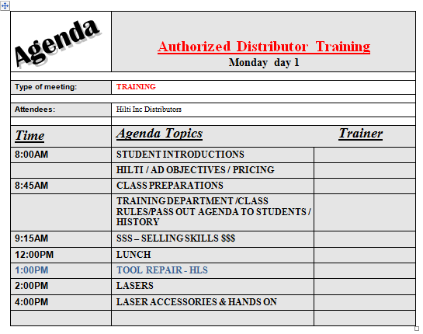

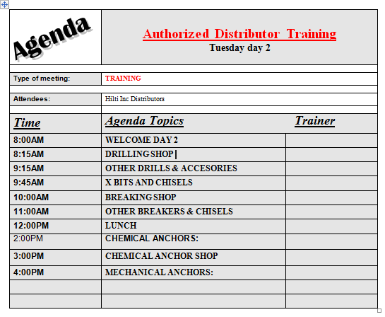

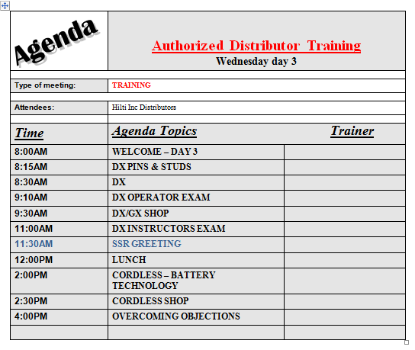

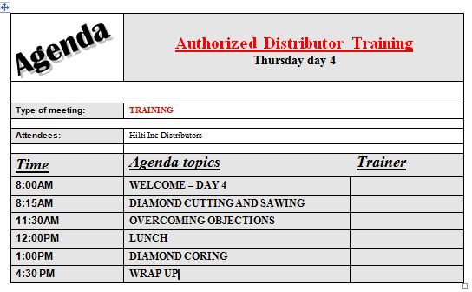

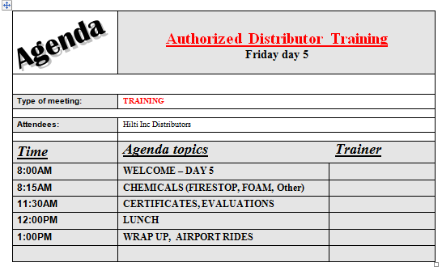

Attachment 2

Map from the Airport to Staybridge Suites

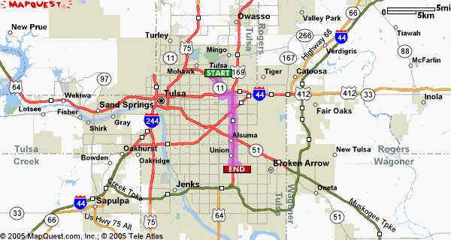

Start | End
Tulsa International Airport | Staybridge Suites - Tulsa
7777 E. Apache Street | 11111 E. 73rd
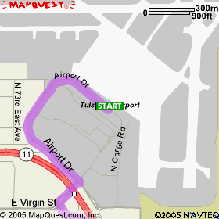
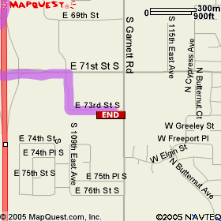

1. | From the airport merge onto OK-11 going south. Veer the LEFT in order to merge onto I-244 toward JOPLIN (go east) | Approx. 2.0 miles
2. | Take I-244 East | Approx. 0.6 miles
3. | Merge onto US-169 South; Exit 71st Street | Approx. 7.0 miles
4. | Turn LEFT onto 71st Street (go east) | Approx. 0.2 miles
5. | Turn RIGHT onto 109th East Ave. (go south)
6. | Turn LEFT onto 73rd Street

Attachment 3

Restaurants and Stores

East of HWY. US-169

Restaurants on 71st Street | Stores/Theaters on 71st Street
Fish Daddy’s | Cinemark Theaters
Cheddars | Albertson’s Grocery
IHOP | Kohl’s
Red Robin | Office Depot
Fox and Hound Sports Bar and Restaurant | Target
Starbucks
Carrabba’s Italian Grill
Abuelo’s Mexican Restaurant
Fuddruckers
New World Buffet

West of HWY. US-169

Restaurants on 71st Street | Stores on 71st Street
Krispy Kreme | Best Buy
Lone Star Steakhouse | Lowe’s
Zio’s Italian Kitchen | Home Depot
El Chico Mexican Restaurant | Dick’s Sporting Goods
Applebee’s | Sam’s Club
Logan’s Roadhouse | Barnes and Noble Books
Outback Steakhouse | Woodland Hills Shopping Mall
On the Border Mexican Cantina
Chili’s

Attachment 4

Map from the Staybridge Suites to Hilti’s Corporate Building

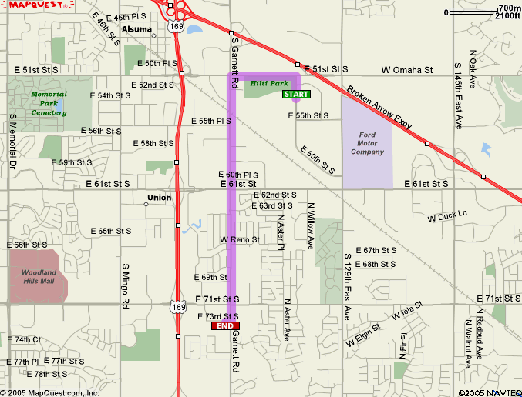

1. | From the hotel take 73rd to Garnett (go east) | Approx. 0.1 miles
2. | Turn LEFT onto Garnett Street (go north) | Approx. 2.1 miles
3. | Turn RIGHT onto 51st Street (go east) | Approx. 1.0 miles
4. | Turn RIGHT onto S. 122nd East Ave Street (go south) | Approx. 0.2 miles
5. | Turn RIGHT into Hilti parking lot

